H2
ANDERSON JUNIOR COLLEGE
HIGHER 2

CANDIDATE
NAME

PDG
INDEX NUMBER
PDG

BIOLOGY
9648/02
Paper 2 Core Paper 11 September 2012
2 hours

Additional Materials: Answer Paper

READ THESE INSTRUCTIONS FIRST
For Examiner’s Use
Section A | 80
1
2
3
4
5
6
7
Section B | 20
8 / 9
Total | 100

Write your name and PD group on all the work you hand in.
Write in dark blue or black pen.
You may use a soft pencil for any diagrams, graph or rough working.
Do not use paper clips, highlighters, glue or correction fluid.

Section A
Answer all questions.

Section B
Answer any one question.

All working for numerical answers must be shown.
At the end of the examination, fasten all your work securely together.
The number of marks is given in brackets [ ] at the end of each question or part question.

Calculators may be used

This document consists of 22 printed pages.

Section A
Answer all the questions in this section.

1 | Fig 1.1 shows the peptidoglycan cell wall of the prokaryote Escherichia coli.  The carbohydrate backbones are made up of two different kinds of sugar: N-acetylmuramate (NAM) and N-acetylglucosamine (NAG). NAM and NAG alternate along the chain and differ from glucose only at the C2 and C3 position.  Fig 1.2 shows the molecular structure of NAM and NAG.  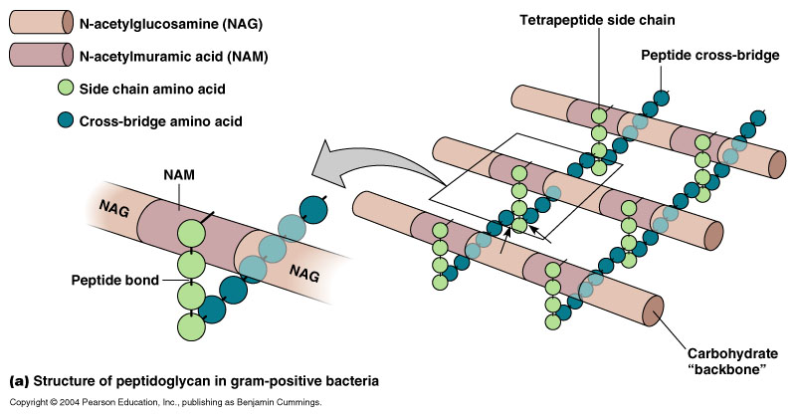  Fig. 1.1  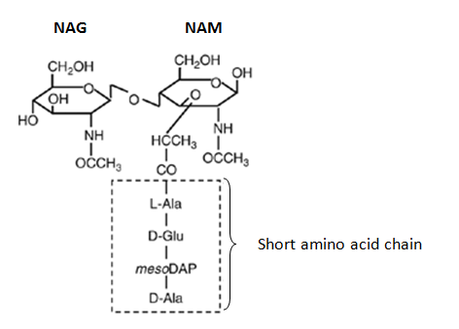  Fig. 1.2
(a) | With reference to Fig 1.1 and Fig. 1.2, describe two ways in which the structure of peptidoglycan:
 | (i) | is similar to cellulose.
 |  | …………………………………………………………………………………………………………..  …………………………………………………………………………………………………………..  …………………………………………………………………………………………………………..  ………………………………………………………………………………………………………….. |  | [2]
 | (ii) | differs from cellulose.  …………………………………………………………………………………………………………..  …………………………………………………………………………………………………………..  …………………………………………………………………………………………………………..  ………………………………………………………………………………………………………….. |  | [2]
(b) | The enzyme lysozyme is found in many pharmaceutical products like eye drop and throat lozenges that treat bacterial infection. Lysozyme is a glycoside hydrolase.  Suggest how the enzyme could be used to treat bacterial infection.
 | ………………………………………………………………………………………………………………….  ………………………………………………………………………………………………………………….  …………………………………………………………………………………………………………………. |  |  | [2]
Fig 1.3 shows the synthesis of the structural protein collagen. Each collagen fibre is made up of numerous triple helix bundled together.

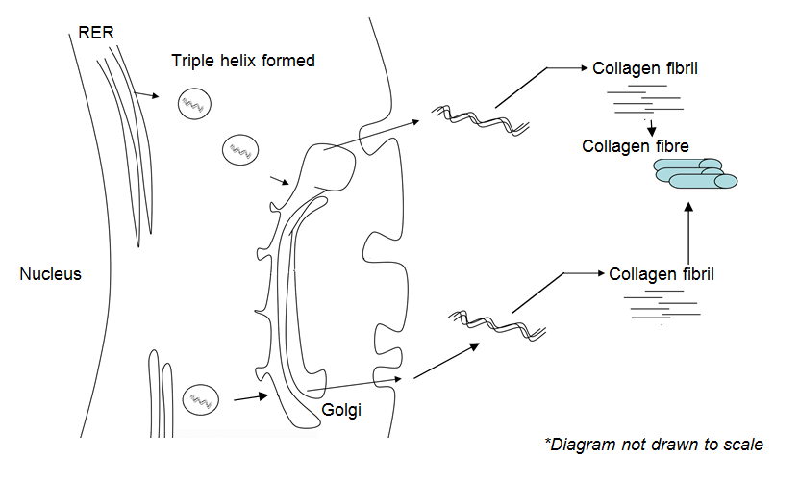

Fig. 1.3

(c) | With reference to Fig 1.3 and using your knowledge of the structure of collagen and protein synthesis, explain how collagen polypeptide chains first synthesized in the rough endoplasmic reticulum would be secreted out of the cell.
 | ………………………………………………………………………………………………………………….  ………………………………………………………………………………………………………………….  ………………………………………………………………………………………………………………….  ………………………………………………………………………………………………………………….  ………………………………………………………………………………………………………………….  …………………………………………………………………………………………………………………. |  |  | [4]
(d) | Suggest why collagen fibres cannot be assembled within the cytoplasm.
 | ………………………………………………………………………………………………………………….  …………………………………………………………………………………………………………………. |  |  | [1]
(e) | Fig 1.4 is an electron micrograph showing collagen fibrils. The fibrils appear banded.  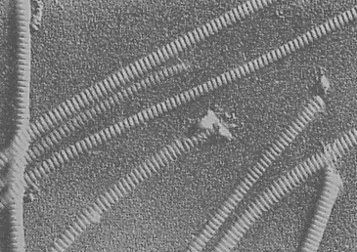  Fig. 1.4
 | Explain how the banded appearance of collagen fibrils contributes to the physical property of collagen.
 | ………………………………………………………………………………………………………………….  ………………………………………………………………………………………………………………….  …………………………………………………………………………………………………………………. |  |  | [2]
[Total : 13]
2 | Fig 2.1 shows photomicrographs of an animal cell undergoing different stages of meiosis.  Fig. 2.1
  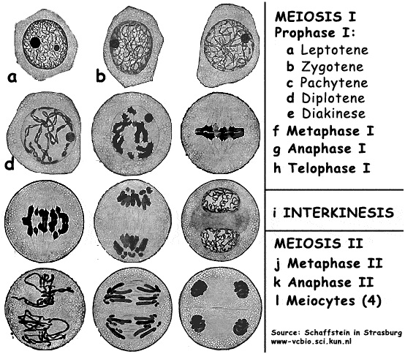A | B | C | D
  E | F | 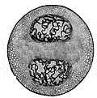G
(a) | With reference to Fig 2.1,
 | (i) | arrange the photomicrographs in successive stages of meiosis.
 |  | ………………………………………………………………………………………………………… |  | [1]
 | (ii) | describe the events that occur at Stage C.
 |  | …………………………………………………………………………………………………………..  …………………………………………………………………………………………………………..  ………………………………………………………………………………………………………….. |  | [2]
(b) | Explain how the second division of meiosis differs from mitosis.
 | ………………………………………………………………………………………………………………….  ………………………………………………………………………………………………………………….  …………………………………………………………………………………………………………………. |  |  | [2]
(c) | The drug Vincristine could be used for the treatment of cancer by arresting mitotic cells at late prophase or early metaphase. It was found that Vincristine exerts its effect on tubulin molecules that make up the microtubules.  In an investigation to compare the effects of Vincristine and another drug Paclitaxel on tubulin molecules, purified tubulin molecules were introduced into a solvent in the absence (Control) and presence of Vincristine and Paclitaxel.  At the end of the investigation, the amount of microtubules formed was measured and the results are shown in Fig. 2.2.  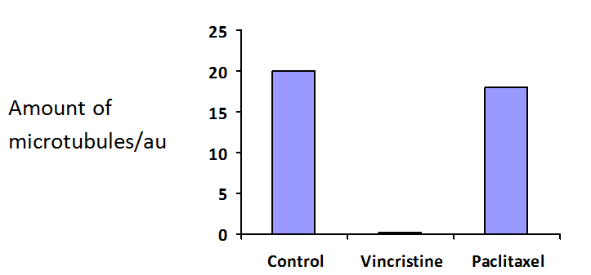  Amount of microtubules / a.u  Fig. 2.2
 | (i) | Explain why Vincristine could be used for treatment of cancer.
 |  | …………………………………………………………………………………………………………..  …………………………………………………………………………………………………………..  ………………………………………………………………………………………………………….. |  | [2]
 | (ii) | With reference to Fig 2.2, explain which drug is more effective for cancer treatment.
 |  | …………………………………………………………………………………………………………..  …………………………………………………………………………………………………………..  ………………………………………………………………………………………………………….. |  | [2]
 | (iii) | Suggest a potential side effect of using Vincristine in cancer treatment.
 |  | …………………………………………………………………………………………………………..  ………………………………………………………………………………………………………….. |  | [1]
Cancer could arise due to errors that occur in DNA replication. One possible error is shown in Fig 2.3.

However, cells have mechanisms that are able to stop cell division, correct the error, before restarting the process again. This prevents the accumulation of genetic errors.

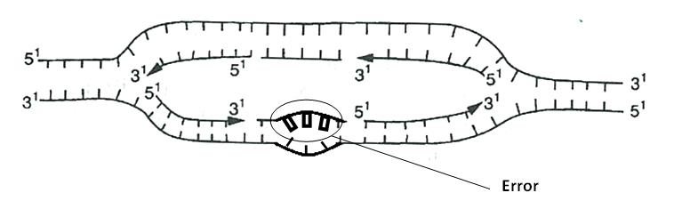
Fig. 2.3

(d) | With reference to Fig 2.3, explain how the error could be corrected.
 | ………………………………………………………………………………………………………………….  ………………………………………………………………………………………………………………….  …………………………………………………………………………………………………………………. |  |  | [2]
 |  |  | [Total : 12]
3
(a) | Explain why viruses are obligate parasites.
 | ………………………………………………………………………………………………………………….  ………………………………………………………………………………………………………………….  …………………………………………………………………………………………………………………. |  |  | [2]
Fig. 3.1 is an electron micrograph showing two human immunodeficiency virus (HIV).

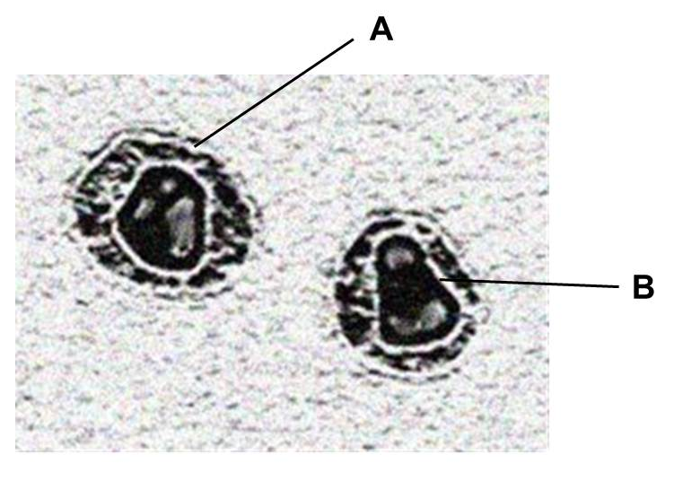
Fig. 3.1

(b) | Identify the structures labeled A and B
 | A | …………………………………………………………………………………………………………..
 | B | ………………………………………………………………………………………………………….. |  | [1]
(c) | Fig. 3.2 shows the changes in HIV proteins concentration and CD4 T-cells count in the bloodstream of an individual after HIV infection.  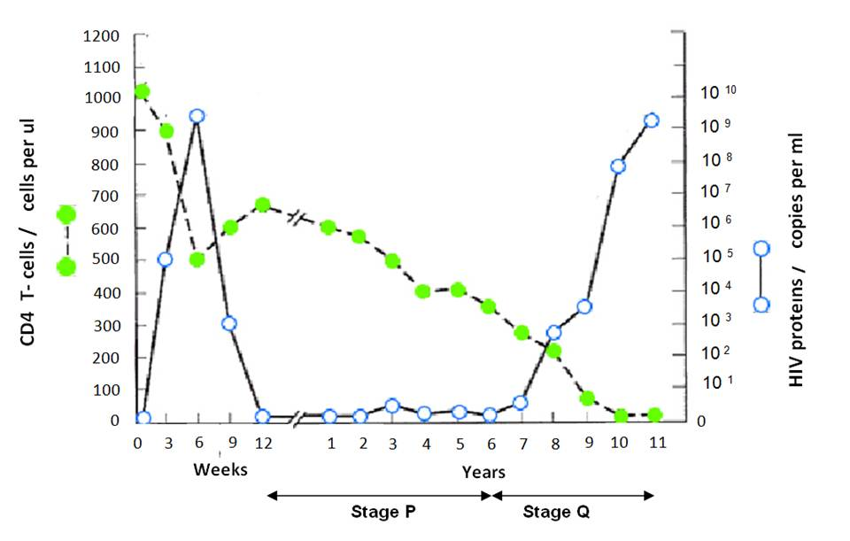  Fig. 3.2
 | (i) | Many cells in Stage P were found to contain viral DNA. Explain the significance of Stage P.
 |  | …………………………………………………………………………………………………………..  …………………………………………………………………………………………………………..  …………………………………………………………………………………………………………..  ………………………………………………………………………………………………………….. |  | [3]
 | (ii) | In an experiment, it was found that the concentration of the enzyme, histone deacetylase (HDAC) in infected cells at Stage P was higher than in infected cells not at Stage P.  Suggest an explanation for the presence of abnormally high levels of HDAC in infected cells at Stage P.
 |  | …………………………………………………………………………………………………………..  …………………………………………………………………………………………………………..  ………………………………………………………………………………………………………….. |  | [2]
 | (iii) | With reference to Fig. 3.2, describe and explain the changes in the amount of HIV proteins and CD4 T-cells count during Stage Q.
 |  | …………………………………………………………………………………………………………..  …………………………………………………………………………………………………………..  …………………………………………………………………………………………………………..  ………………………………………………………………………………………………………….. |  | [2]
Figure 3.3 is a phylogenetic tree showing the evolutionary relationships between a form of HIV (HIV-1) and the retrovirus, Simian immunodeficiency virus (SIV) that afflicts non-human primates. The phylogenetic tree was constructed based on molecular techniques.

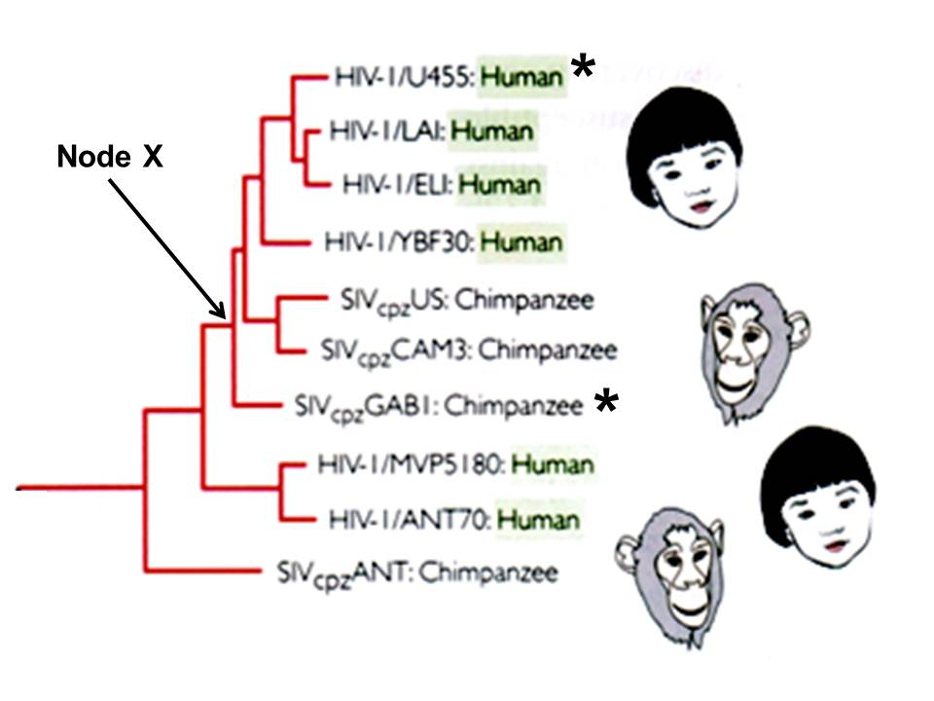
Fig. 3.3
(d) | State
 | (i) | the name of a gene which scientists used to construct the above phylogenetic tree.
 |  | ………………………………………………………………………………………………………….. |  | [1]
 | (ii) | the relationship between Node X, HIV-1/ U455: Human ( denoted with *) and SIVcpz GABI: Chimpanzee (denoted with *)
 |  | …………………………………………………………………………………………………………..  ………………………………………………………………………………………………………….. |  | [1]
(e) | Suggest why fossil records, normally used as evidence to study evolutionary relationships were inappropriate in the construction of this phylogenetic tree.
 | ………………………………………………………………………………………………………………….  …………………………………………………………………………………………………………………. |  |  | [1]
 |  | [Total : 13]
4 | Control of gene expression functions in a wide range of developmental processes including sex determination.  In Drosophila melanogaster the doublesex (dsx) protein is crucial in the development of sexual phenotype. In males, the presence of dsx-m activates the transcription of genes which products control male sexual development while the presence of its isomer, dsx-f in females represses the transcription of genes whose products control male sexual development.  Fig. 4.1 shows the structure of the dsx-m protein which has a DNA-binding domain and protein binding domain.  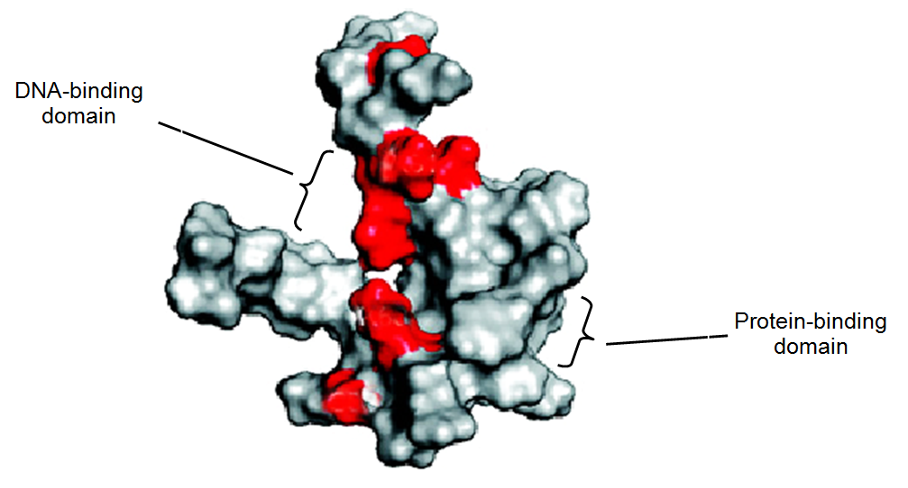  Fig. 4.1
(a) | (i) | State the general name given to proteins like dsx-m and dsx-f.
 |  | ………………………………………………………………………………………………………… |  | [1]
 | (ii) | Explain why the dsx-m protein contains both a DNA-binding domain and a protein-binding domain.
 |  | …………………………………………………………………………………………………………..  …………………………………………………………………………………………………………..  …………………………………………………………………………………………………………..  ………………………………………………………………………………………………………….. |  | [3]
(b) | It was found that male Drosophila flies showing female characteristics mostly have an amino acid substitution at the DNA-binding domain of the dsx-m protein.  The shaded areas in Fig. 4.1 show the positions of amino acid substitutions presumed to affect the DNA-binding domain.
 | (i) | Explain why an amino acid substitution within the DNA-binding domain can affect the function of the dsx-m protein.
 |  | …………………………………………………………………………………………………………..  …………………………………………………………………………………………………………..  …………………………………………………………………………………………………………..  ………………………………………………………………………………………………………….. |  | [3]
 | (ii) | Suggest why amino acid substitutions that occur outside of the DNA–binding domain can also affect the function of the dsx-m protein.
 |  | …………………………………………………………………………………………………………..  …………………………………………………………………………………………………………..  ………………………………………………………………………………………………………….. |  | [2]
(c) | While control of transcription is important in Drosophila sex determination, the nematode worm, Caenorhabditis elegans (C. elegans) depends on translational control of two important genes, Tra2 and Fem3 to determine sex.  Most C. elegans are hermaphroditic (have reproductive organs of both sexes), producing both  sperm and eggs at different times. When expressed, Tra2 promotes the development of eggs and  Fem3 promotes the development of sperm.  Fig. 4.2 shows the translational control of Tra2 and Fem3.  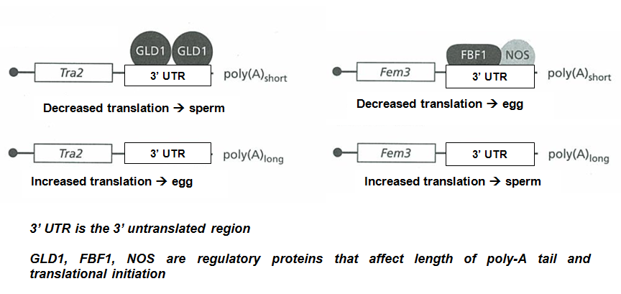  Fig. 4.2
 | (i) | State in which cell type of the C. elegans does translational control of Tra2 and Fem3 occurs.
 |  | ………………………………………………………………………………………………………….. |  | [1]
 | (ii) | Describe and explain the effect of length of poly-A tail on gene expression.
 |  | …………………………………………………………………………………………………………..  …………………………………………………………………………………………………………..  ………………………………………………………………………………………………………….. |  | [2]
 | (iii) | Suggest the role of regulatory proteins such as GLD1, FBF1 and NOS in controlling gene expression.
 |  | …………………………………………………………………………………………………………..  ………………………………………………………………………………………………………… |  | [1]
 |  | [Total: 13]
5 | Different pure-bred lines of chickens show pronounced differences in mortality following infection with equal doses of two different strains of the bacterium Salmonella typhimurium.  In an investigation into the inheritance of resistance, a series of crosses was performed between two pure-bred lines of White Leghorn chickens, one line resistant to infection by the bacterium and one susceptible. The results of infecting newly hatched chicks of each purebred line, and of the cross between a susceptible male and a resistant female, are shown in Table 5.1.  Table 5.1  Infecting the F1 offspring with either the F98 or Swindon strain results in the same conclusion drawn about the inheritance of resistance to S.typhimurium.  It is thought that resistance to S.typhimurium is controlled by a single gene.
  line of chickens | mortality / % chicks infected
  line of chickens | strain of S. typhimurium
  line of chickens | F98 | Swindon
  resistant | 40.0 | 0.0
  susceptible | 100.0 | 35.7
  F1 offspring from cross between susceptible male and resistant female | 45.0 | 0.0
(a) | (i) | Using suitable symbols, draw a genetic diagram to show how resistance to S.typhimurium could be inherited in the cross as shown in Table 5.1. |  | [4]
 | (ii) | Suggest why the resistance of the chicks to the two different strains of S.typhimurium shown in Table 5.1 is different.
 |  | …………………………………………………………………………………………………………..  ………………………………………………………………………………………………………… |  | [1]
(b) | When 20 chicks from crossing a susceptible male and a resistant female were infected with equal doses of strain F98 of S. typhimurium, 9 died, but when 19 chicks from the reciprocal cross of a resistant male and a susceptible female were infected with equal doses of the same strain of bacterium, only 3 died. In both cases, 40% of the chicks were expected to die.
 | (i) | State two reasons why the observed results of such crosses may be different from the expected results.
 |  | …………………………………………………………………………………………………………..  …………………………………………………………………………………………………………  ………………………………………………………………………………………………………… |  | [2]
 | (ii) | Use the chi-squared test and the table of probabilities shown in Table 5.2 to find the probability of the results of the reciprocal cross described above (resistant male and susceptible female) differing from the expected results due to chance alone.  Show your working.  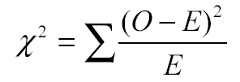  Table 5.2  Probability: ………………………….. |  | [2]
  degrees of freedom | probability, p
  degrees of freedom | 0.10 | 0.05 | 0.02 | 0.01 | 0.001
  1 | 2.71 | 3.84 | 5.41 | 6.64 | 10.83
  2 | 4.61 | 5.99 | 7.82 | 9.21 | 13.82
  3 | 6.25 | 7.82 | 9.84 | 11.35 | 16.27
  4 | 7.78 | 9.49 | 11.67 | 13.28 | 18.47
 | (iii) | State the conclusion that can be drawn from your calculation of χ² value.  …………………………………………………………………………………………………………..  …………………………………………………………………………………………………………  ………………………………………………………………………………………………………… |  | [2]
 | [Total: 11]
6 | A comparative study on insect mouthparts is used to provide evidence for evolution. Table 6.1 shows the structure of the mouthparts of various insects and their functions.  Insect mouthparts consist of:  - a pair of maxillae (upper jawbone) mx  - a pair of mandibles (lower jawbone), md  - a labrum (upper lip), lr  - and a labium (lower lip) lb  Table 6.1
  Insect | Structure of mouthparts |  | Function
  Butterfly | 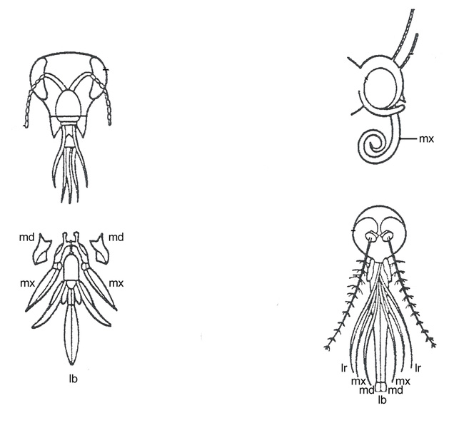 | Maxillae (mx) are long, forming sucking tubes  Mandibles (md) are lost  Labrum (lr) is reduced  Labium (lb) is reduced | Sucking
  Honey bee |  | Mandibles (md) are used to chew pollen and mould wax  Labium (lb) is long to lap up nectar | Licking and biting
  Female mosquito |  | Mandibles (md) form piercing stylets  Maxillae (mx) and labrum (lr) form sucking tube  Labium (lb) is grooved to hold other parts | Piercing and sucking
(a) | (i) | What is the term used to describe the relationship between structures such as those shown in Table 6.1?  ………………………………………………………………………………………………………….. |  | [1]
 | (ii) | Explain how the relationship between different insect mouthparts provides evidence to support the theory of evolution.  …………………………………………………………………………………………………………..  …………………………………………………………………………………………………………  …………………………………………………………………………………………………………  ……………………………………………………………………………………………………….. |  | [3]
(b) | Suggest how natural selection could have brought about the evolution in the length of mandibles in female mosquitos.
 | ………………………………………………………………………………………………………………….  ………………………………………………………………………………………………………………….  ………………………………………………………………………………………………………………….  ………………………………………………………………………………………………………………….  …………………………………………………………………………………………………………………. |  |  | [4]
 |  |  | [Total : 8]
7 | Fig. 7.1 shows the sequence of events in the glucagon signaling pathway in a hepatocyte.  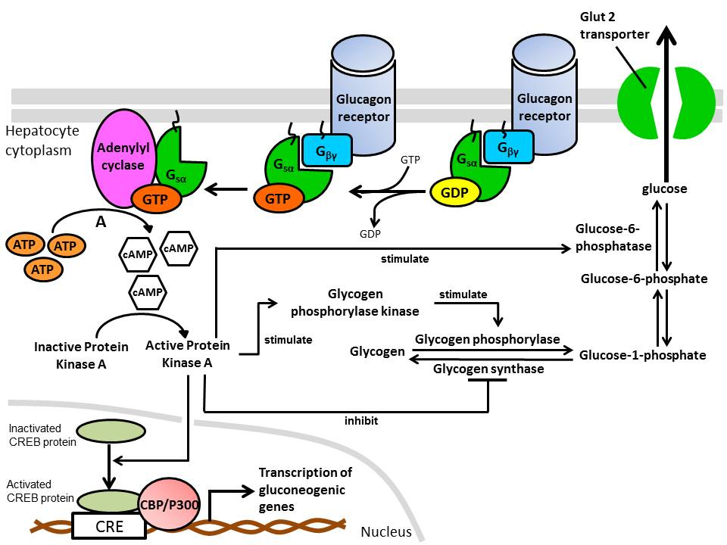  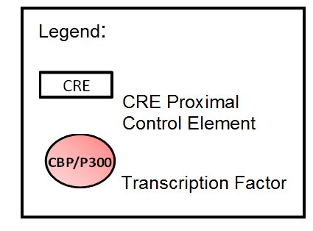  Fig. 7.1  Stage A
(a) | (i) | Describe how the binding of G_{sα} subunit would activate adenylyl cyclase.
 |  | …………………………………………………………………………………………………………..  …………………………………………………………………………………………………………  ………………………………………………………………………………………………………… |  | [2]
 | (ii) | Explain how Stage A shows signal amplification.
 |  | …………………………………………………………………………………………………………..  ………………………………………………………………………………………………………… |  | [1]
 | (iii) | Explain how activation of Protein Kinase A leads to increase in blood glucose concentration.
 |  | …………………………………………………………………………………………………………..  …………………………………………………………………………………………………………  …………………………………………………………………………………………………………  ………………………………………………………………………………………………………..  ……………………………………………………………………………………………………….. |  | [4]
(b) | Gluconeogenic genes code for proteins that are involved in the synthesis of glucose in cells.  With reference to Fig.7.1, state a gluconeogenic gene that will be transcribed due to the activation of CREB protein.
 | …………………………………………………………………………………………………………………. |  |  | [1]
(c) | When glucagon levels in the environment remain high for several hours, cells usually undergo desensitization, such that they no longer respond to that concentration of hormone. This prevents excessive and prolonged receptor activity.  Suggest how cells can decrease the stimulation of receptor molecules by the presence of high concentration of ligands.
 | ………………………………………………………………………………………………………………….  ………………………………………………………………………………………………………………….  …………………………………………………………………………………………………………………. |  |  | [2]
 |  |  | [Total : 10]
Section B

Answer one question.

Write your answers on the separate answer paper provided.
Your answer should be illustrated by large, clearly labeled diagrams, where appropriate.
Your answers must be in continuous prose, where appropriate.
Your answers must be set out in section (a), (b) etc., as indicated in the question.
8 | (a) | Explain how genetic variation may be preserved in a natural population. |  | [8]
 | (b) | Besides gene mutation, outline the ways in which bacteria acquire genetic variation. |  | [8]
 | (c) | Distinguish between gene mutation and chromosomal aberration. |  | [4]
9 | (a) | Describe, with named examples, the roles of membrane proteins in respiration and in the transmission of an action potential along an axon. |  | [8]
 | (b) | Explain how temporal and spatial summation lead to nerve impulse transmission at the postsynaptic neurone. |  | [4]
 | (c) | Outline how glyceraldehyde 3-phosphate is made in the Calvin cycle and converted into starch and discuss the suitability of starch as a plant storage compound. |  | [8]

Legend:

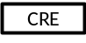 CRE Proximal Control Element
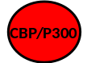Transcription Factor

Legend:

CRE Proximal Control Element
Transcription Factor

